# Group Report Weeks 1 – 5

Group name: Goku

Group Members: Aidan Willis, James Sadler

## Assigned Tasks

Stakeholder report: James

Persona 1: James

Persona 2: Both

Group Meeting report: Aidan

Persona 3: Aidan

## James

Stakeholder registry

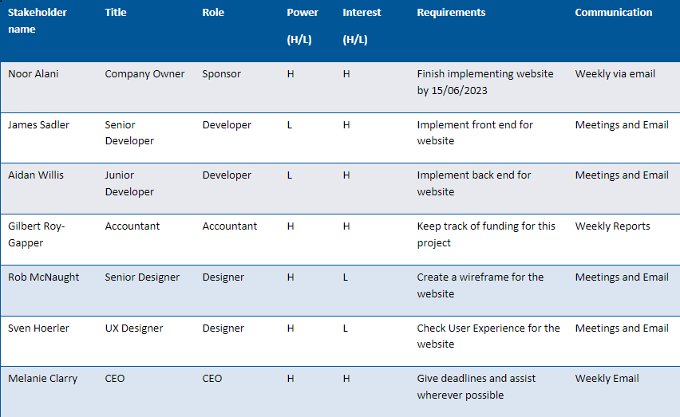

### Week 1

Initially on our first week we were thinking of working on a game we’ve had planned for a while now. This game is a simple platformer game that was made in a game engine called Godot. Eventually we both decided against this as we were running out of time to both make the game and deal with all the other assessments.

### Week 2-3

I primarily dealt with making the stake holder report for the project we’re working on. This involved thinking of roles that would be important for our project such as front end and back-end developers, Designers for the User Interface and some other different roles.

These roles also include power levels over the entire project with developers having low power over the project but the sponsor and the CEO of the company having high power over this as they would have the most power over the entire project as they are paying for it.

### Week 4

This week I primarily dealt with making the finishing touches to the stake holder registry for any missing roles such as CEO and some more designers for a layout of the website. I also started setting up a markdown file for a GitHub repository for all our files to go into. I also started working on the personas required.

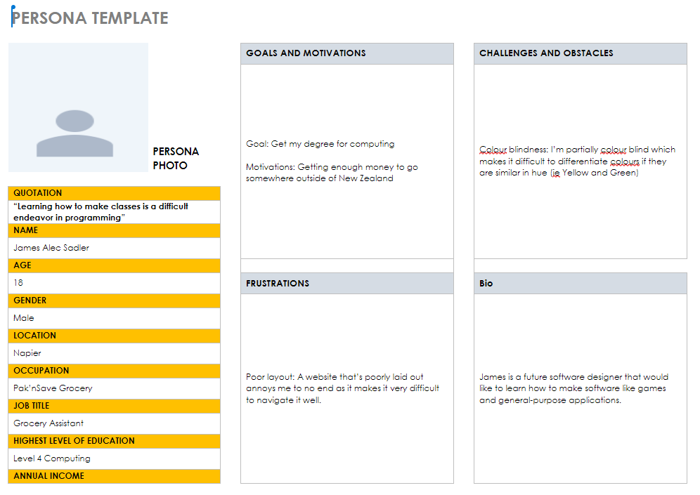

Note: I’m not actually colourblind. It's more adding something for someone that is colourblind would struggle with.

### Week 5

I taught Aidan how to use Git Bash. I covered how to add initialize using git, committing files and adding files via bash. This will help him use git in the future with this project as we’re dealing with making a GitHub repository as I mentioned.

## Aidan

Group meeting report

### Week 1: The first challenges

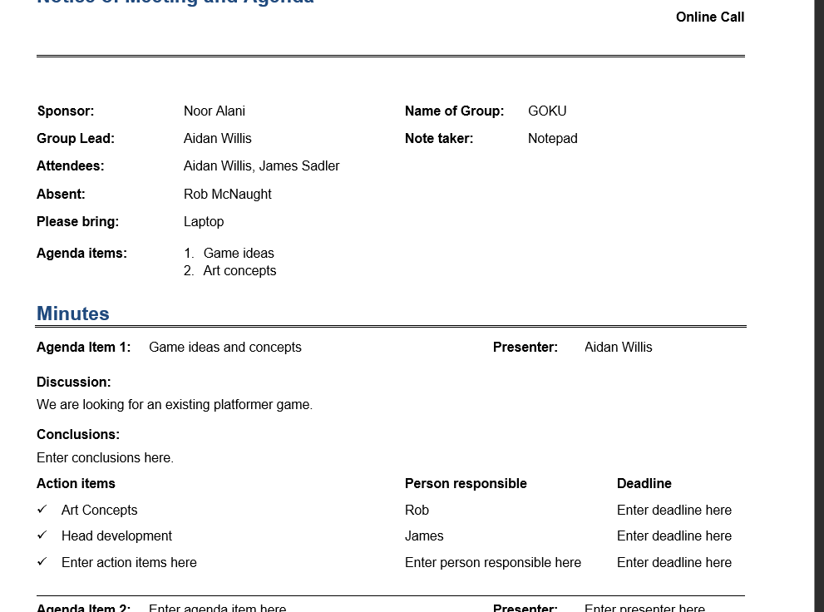

With the first week, James and I were thinking about making the task make more sense to us and be about something we are both more passionate about this then led to more work and more issues latter down the track, so we decided to stick with the original plan.

### Week 2

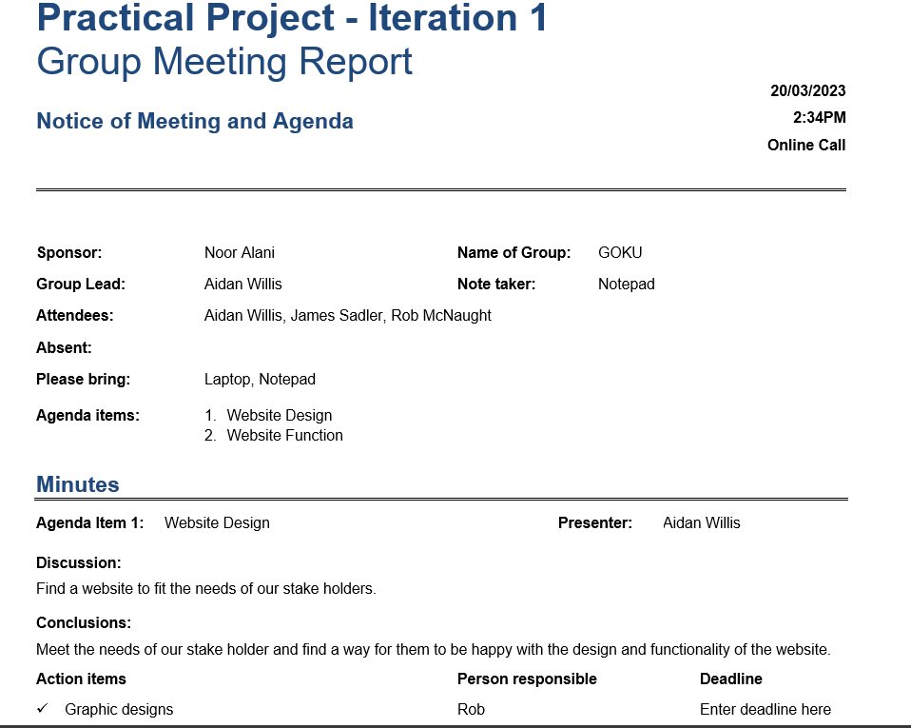

In week 2 we went back to basics, so I had to reform the document and think more professionally and give different roles to team members. With different roles, we need more new team members.

### Week 3

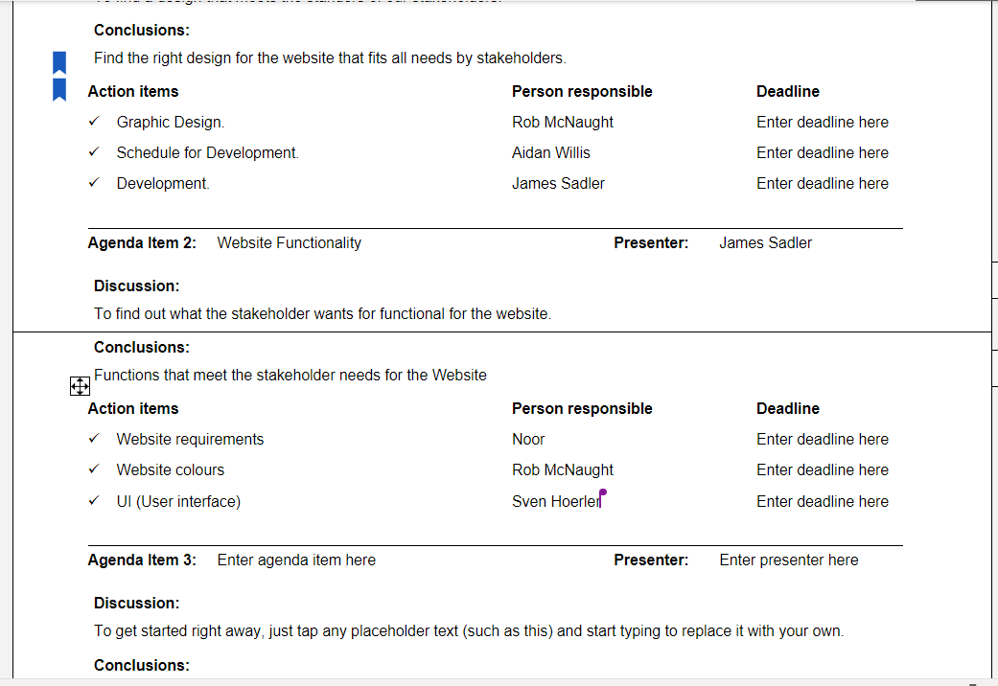

With week 3 I finalized the first agenda and imputed the 2nd agenda James, and I are still unsure about deadlines so will wait to finish or until we figure out what coherent timeline, we want to portray.

### Week 4-5

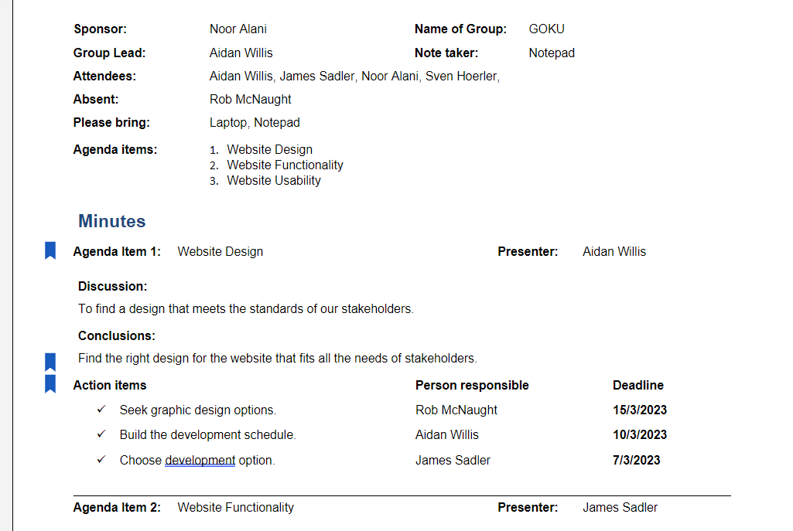

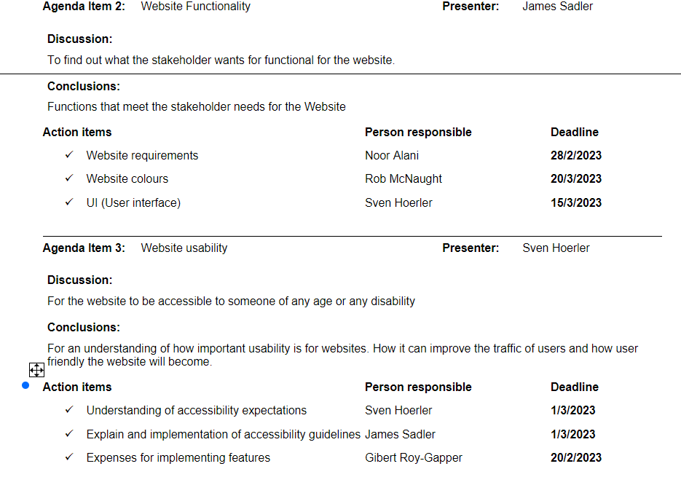

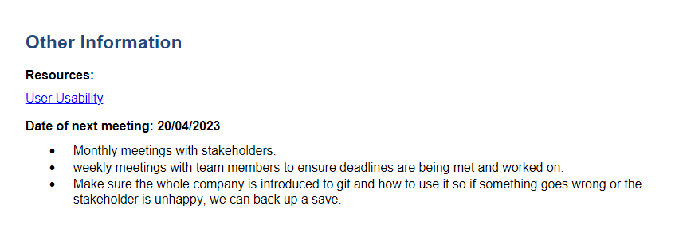

In these weeks I finalized the deadlines. With help from James, all the spelling mistakes were cleared up. We also looked at personas and did one each and then went to a friend and interviewed them and made the third persona and then finished up on the group report.

## Group Issues

### Issues we’ve come across

Communication: A major issue we’ve both come across is dealing with a lack of communication between us. We’ve dealt with online classes separately before and none were awfully successful (especially during the COVID pandemic).

### Issues dealt with and how we fixed them

Communication: Initially we thought of using Discord which is an online communication application, which did not help at all. Our fix was for one of us to go to the others house to work together in one room instead of separated as this would help with our lack of focus and communication.

### Challenges

Motivation: Both me and Aidan have been struggling to stay motivated to do work for any class as we’re more focused within a classroom compared to being at home where there’s many ways to get distracted from doing work such as social media or video games. Being together in one room (as mentioned above) has kept us more focused on our work.

### Achievements

Working with our schedule: Both of us struggled to stay on schedule and work with each other as gigantic lack of communication between us lead to us struggling to work together. By following a schedule of one of us going to the others house has led to us being able to start working together properly with communication.